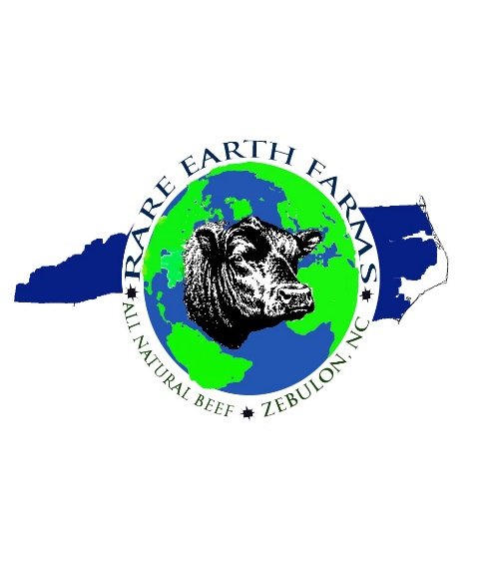
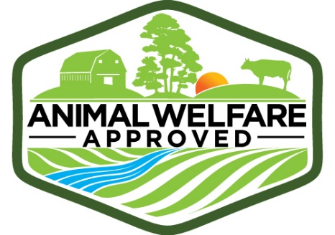

Rare Earth Farms, LLC
2019 CSA Sign-Up Sheet
Name: _______________________________________________
Address: _____________________________________________
_____________________________________________
City, St, Zip: ___________________________________________
Home Phone: __________________________________________
Cell Phone: ____________________________________________
Fax #: _________________________________________________
Email: _________________________________________________
How would you prefer to be contacted each month? Please check preference.
Email ________ Cell Phone _______ Home Phone _______ Text _______

Date Paid _________ Share Payment in Full $565, including sales tax. We accept cash or personal checks payable to Rare Earth Farms.

Signature ___________________________________

1st Pick up Date: August 2019. 10lbs in Aug/Oct/Dec/Feb/Apr/June.
You will be notified the first or second week of every other month when your CSA is available for pickup. You can pick up any day of the week BUT Monday & Tuesday at the NC State Farmer’s Market, Lake Wheeler Rd, Raleigh, NC

Rare Earth Farms Contact Info:
Karl Hudson 919-349-6080 karlhudson@rareearthfarms.com
Mann Mullen 919-496-2980 mannmullen@rareearthfarms.com
Mail payment to: Karl Hudson, Rare Earth Farms, 2416 White Oak Rd. Raleigh, NC 27609
2018 RARE EARTH FARMS CSA PLAN

Rare Earth Farms is pleased to offer the following CSA for 2019. This will be our ninth year offering a CSA to our customers and our prior experience has allowed us to continually improve our CSA.

CSA Members will receive 10 lbs of Rare Earth Farms’ all-natural, grass-fed, grass-finished beef every other month for an entire year during 2019/2020.

The first CSA package will be ready for pickup at our booth at the Sate Farmer’s Market in August 2019. All members will be notified prior to CSA pickup that their package is ready.

2019 CSA 10 lb packages will be scheduled for the following six months: August, October, December, February, April and June.

Members have the flexibility to pick their package up from our booth at the State Farmer’s Market any day except Mondays &Tuesdays after the “ready” date.

Spring/Summer package months, (August, April, June) will consist of traditional warm weather cuts such as steaks, hamburgers, ribs, kabobs, flank, etc.

Fall/Winter packages (October, December, February) will consist of roasts, stew beef, ground beef, brisket, cube steak, etc.

2019 CSA Annual Membership Cost: $565.00 including NC Sales Tax
The 2019 CSA will be a $600-$650 value for an annual savings of $75-$125.

Signup for the CSA will begin the month of June at our State Farmer’s Market Rare Earth Farms booth or by mail: Rare Earth Farms, 2416 White Oak Road, Raleigh, NC 27609

Payment is due in full prior to January pickup. We accept personal checks and cash only.

*** PAYMENTS ARE NONREFUNDABLE AFTER DELIVERIES BEGIN***

